Walkthrough 27 Mock Server Configuration

https://sapui5.hana.ondemand.com/#/topic/bae9d90d2e9c4206889368f04edab508

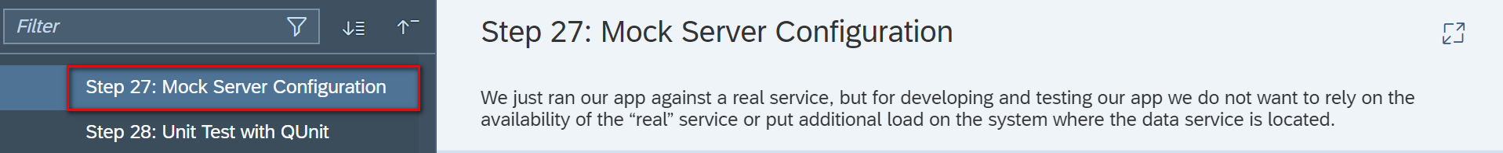

Core Changed Codes Compared to Last Version:

1.html方式加载Component.js

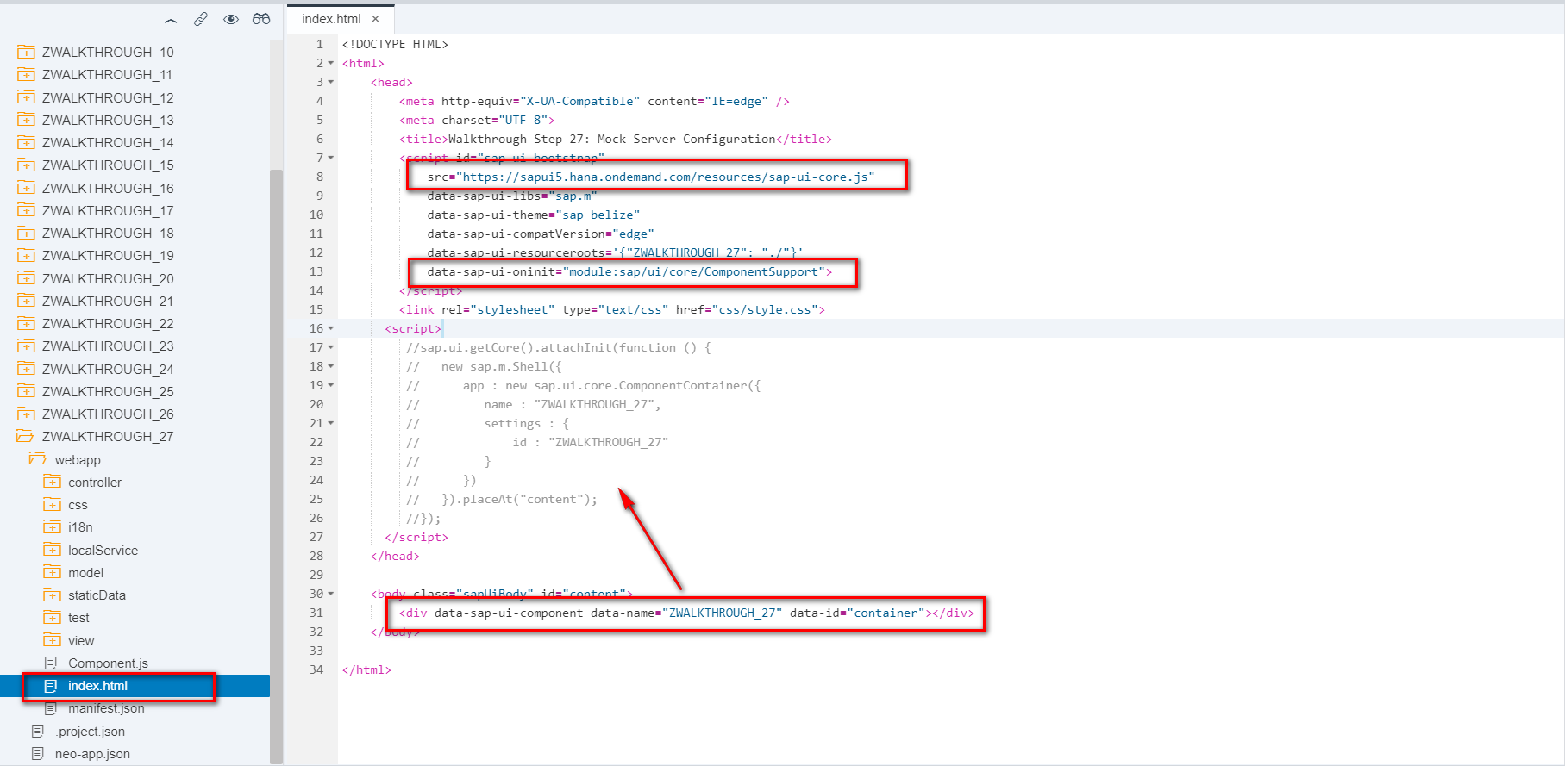

结果:无Shell容器

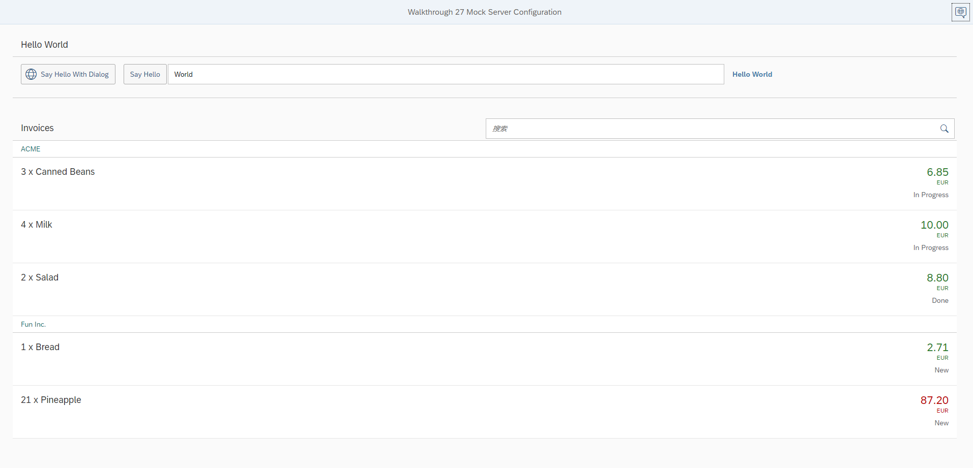

2.Mock Server方式

2.1 test/mockServer.html

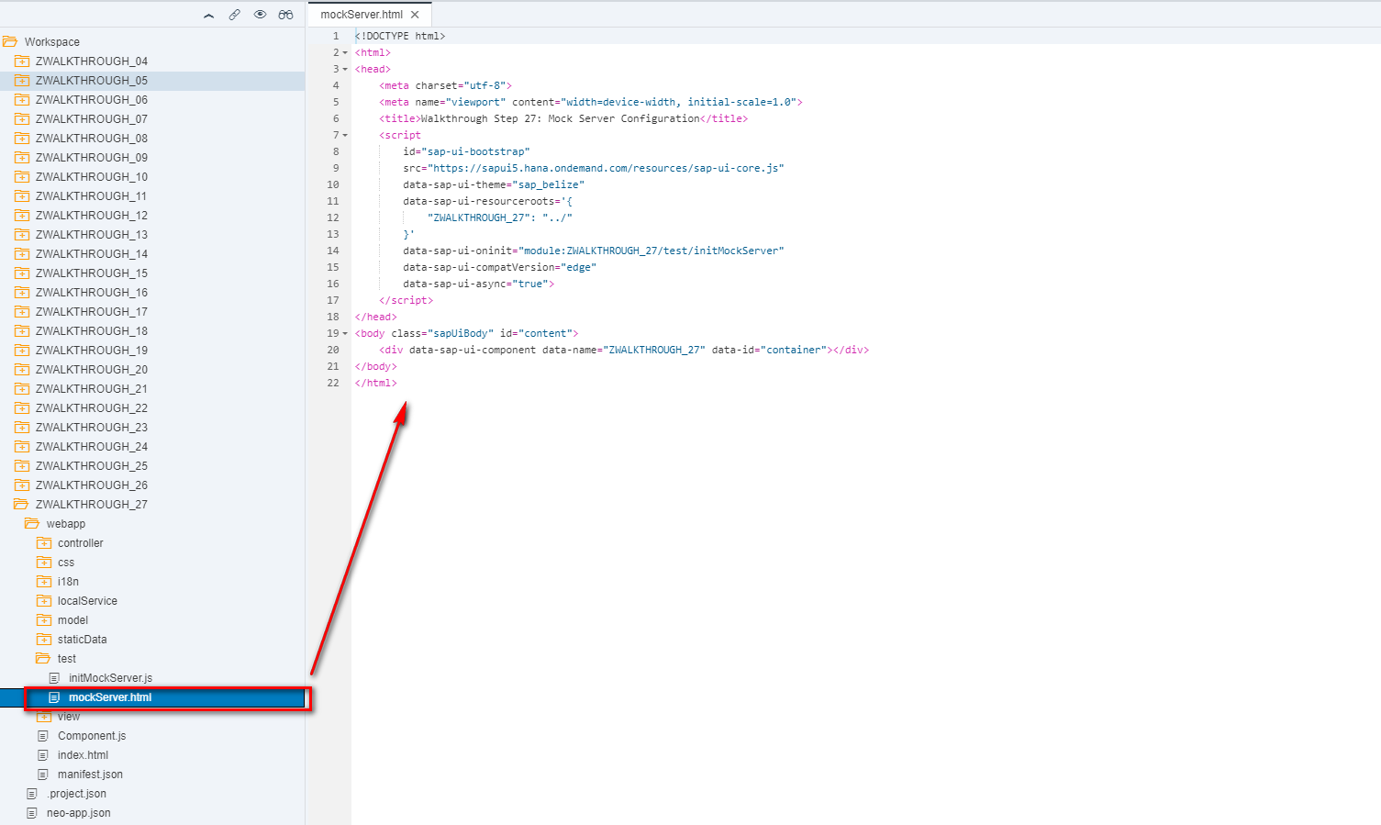

2.2 test/initMockServer.js

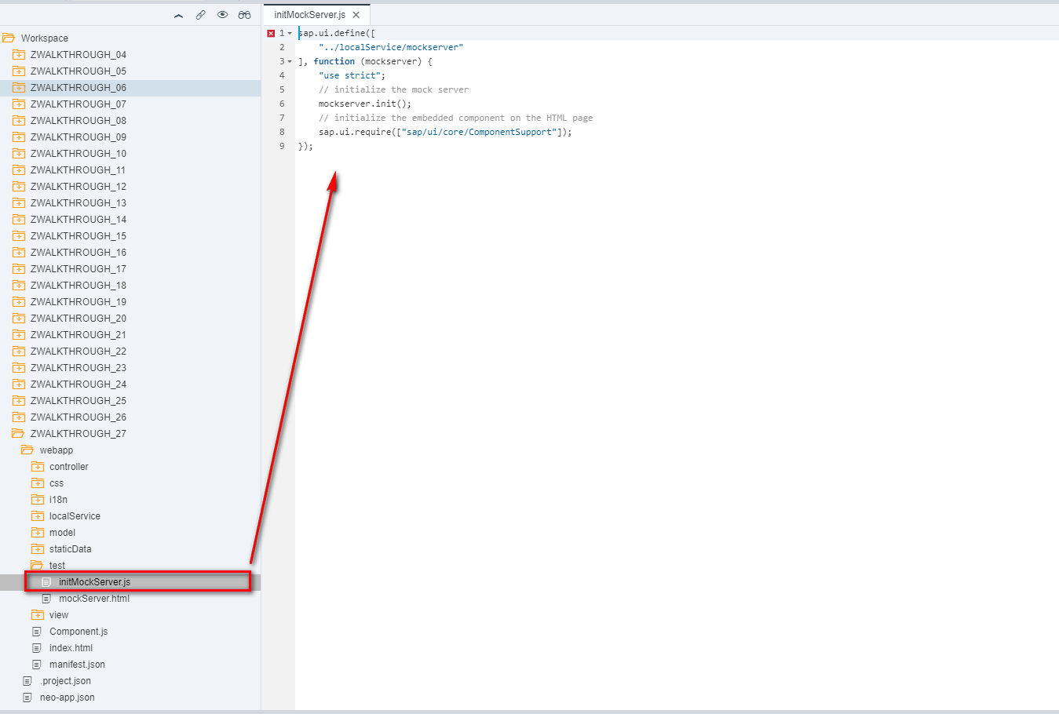

2.3 localService/mockserver.js

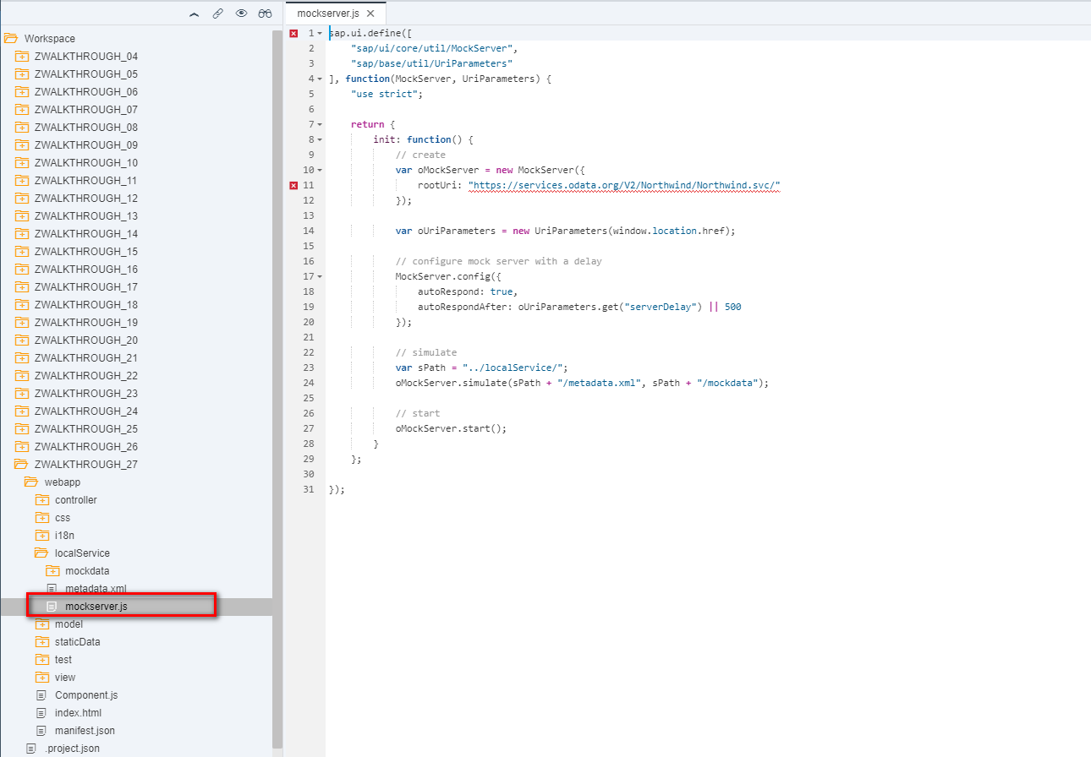

2.4 localService/mockserver.js

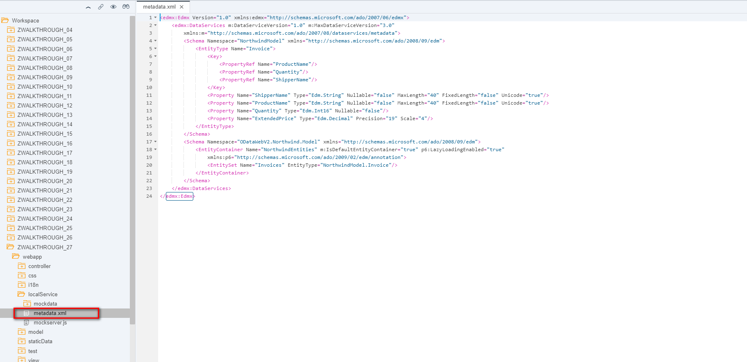

2.5 localService/mockdata/Invoices.json

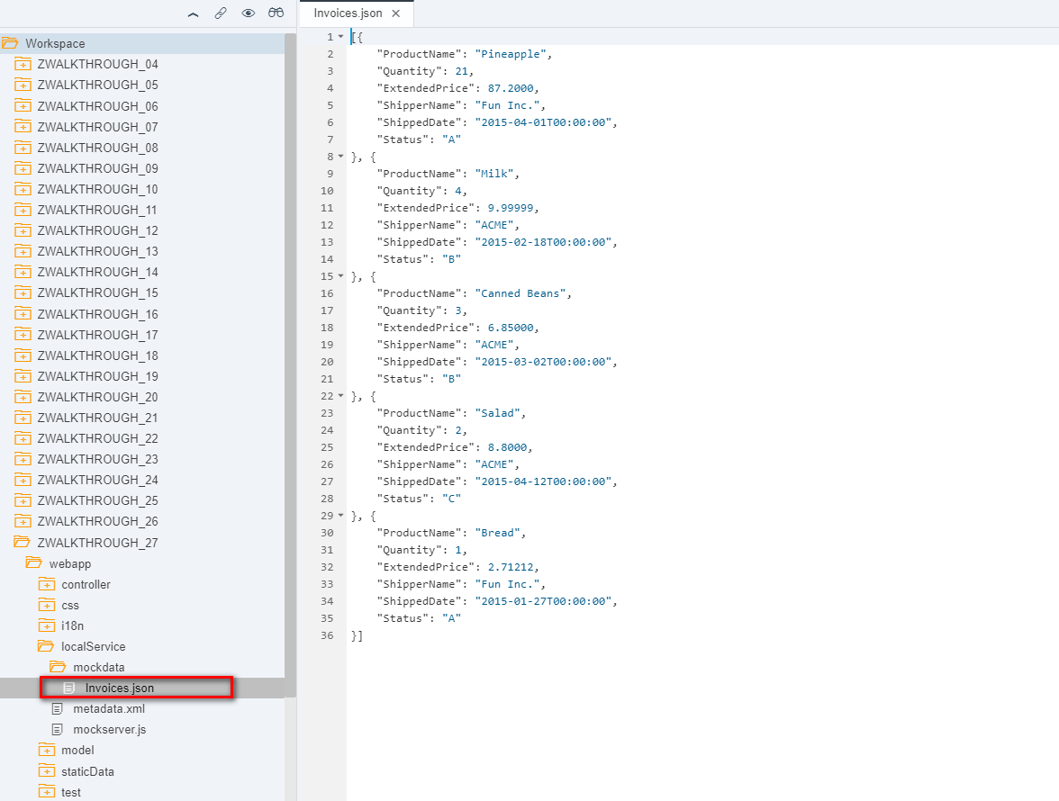

i18n 文本对象管理

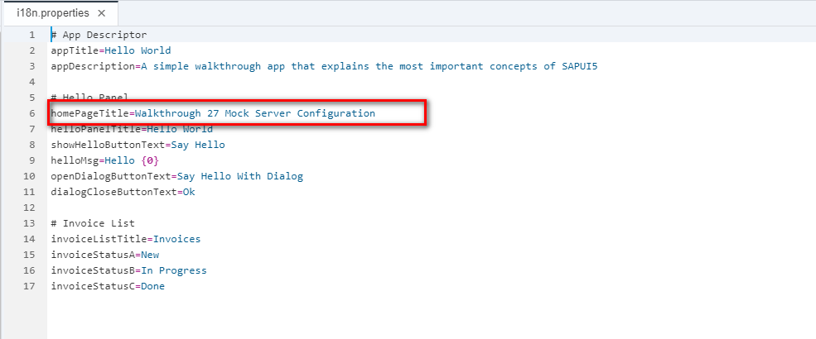

Result

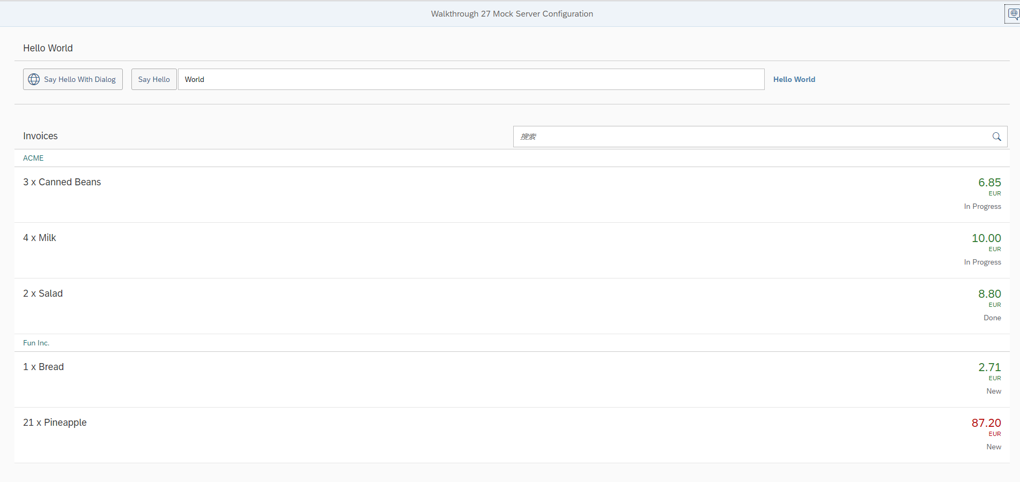

Network

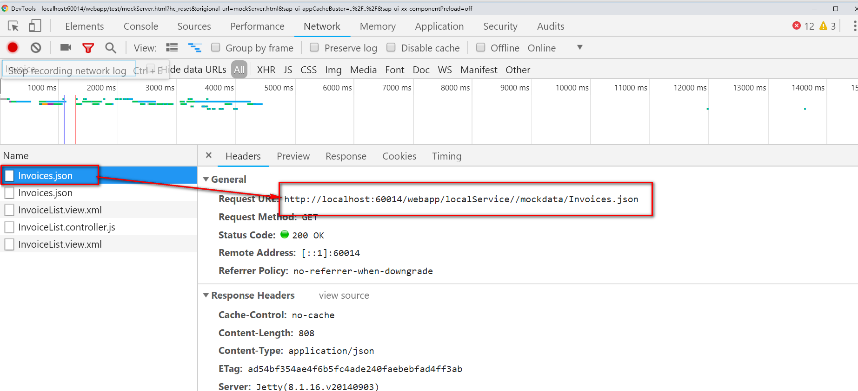

Git:

https://github.com/xiexiaop/SAPUI5-2-Round/tree/master/Projects/ZWALKTHROUGH_27

2019/02/06 XiaoMi Beijing Zac,Xie